Task 5 : Capture and Analyze Network Traffic Using Wireshark.
Objective: Capture live network packets and identify basic protocols and traffic types.
Tools: Wireshark (free).
Deliverables: A packet capture (.pcap) file and a short report of protocols identified.

1.Install Wireshark.
- Installed Wireshark using command.
- sudo apt install Wireshark.
2.Start capturing on your active network interface.
Open Wireshark.
Look at the list of available interfaces and click on eth0.
Start capturing on the one with live traffic.
3.Browse a website or ping a server to generate traffic.
Use a command: ping google.com
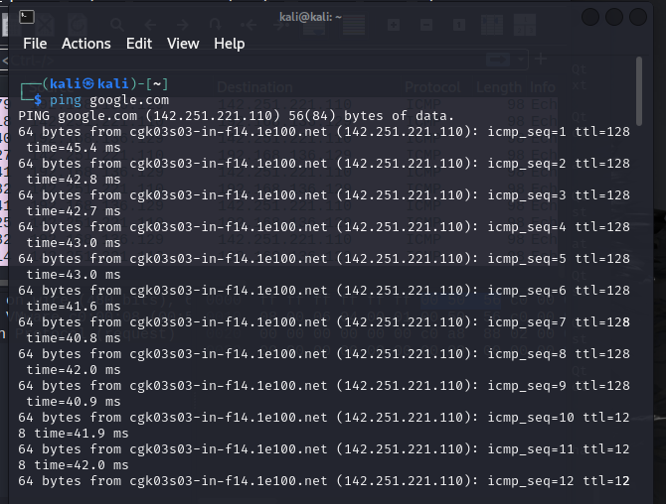
It starts pinging to google.com and starts capturing the data in Wireshark.
4.Stop capture after a minute.
After one minute stop the capture by clicking on the red square button on top of Wireshark.
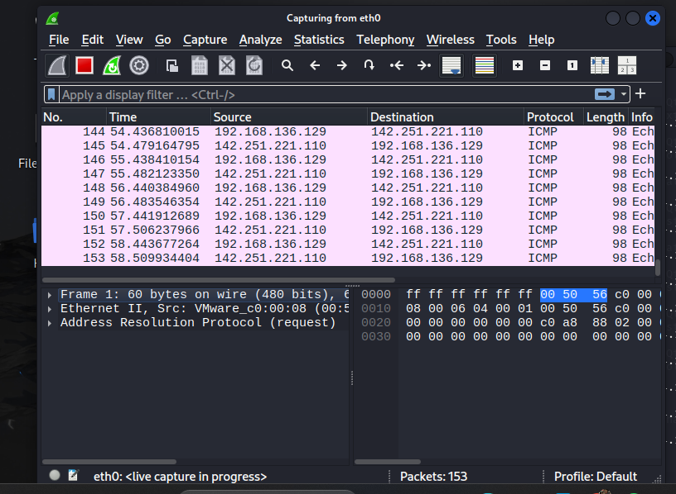
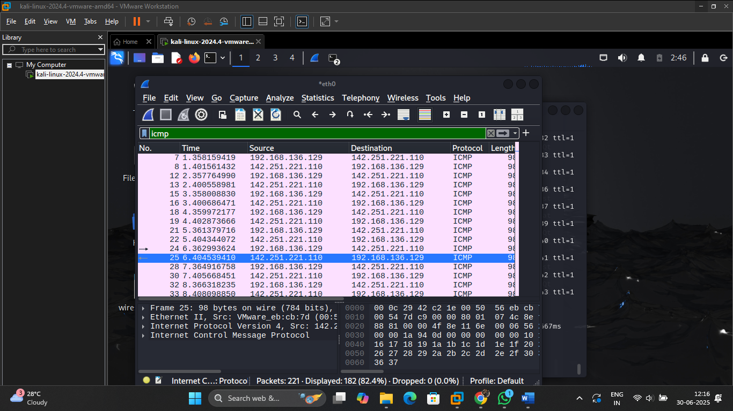
5.Filter captured packets by protocol (e.g., HTTP, DNS, TCP).
DNS, ARP, ICMP, MDNS are the protocol filters found in captured packets.
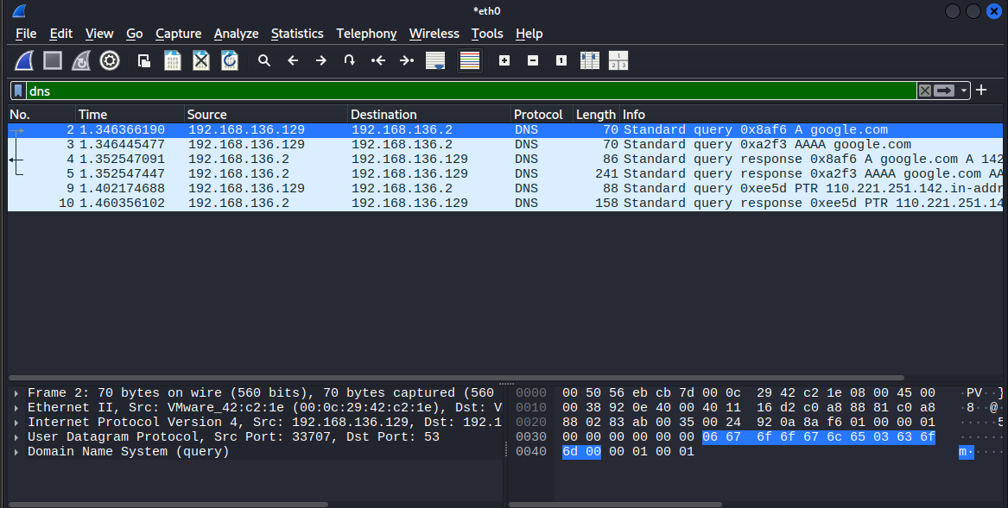
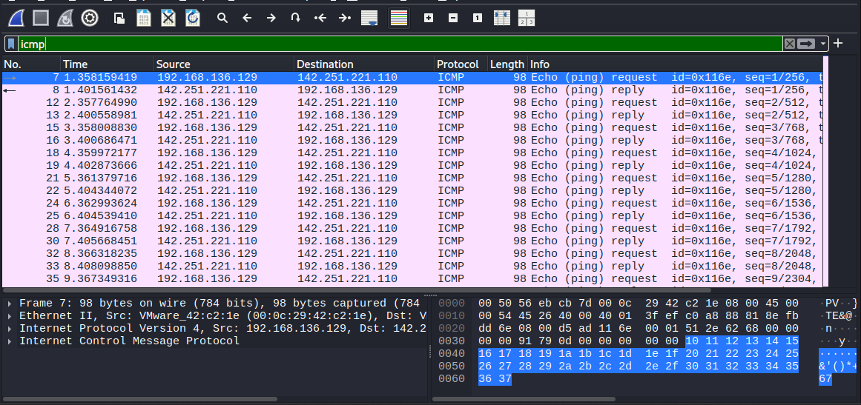
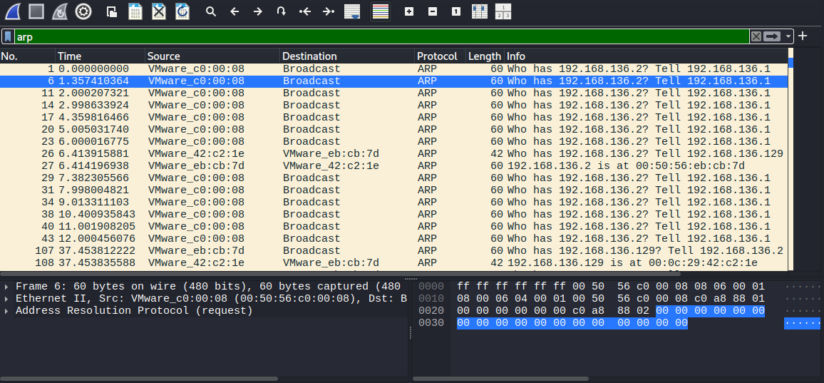
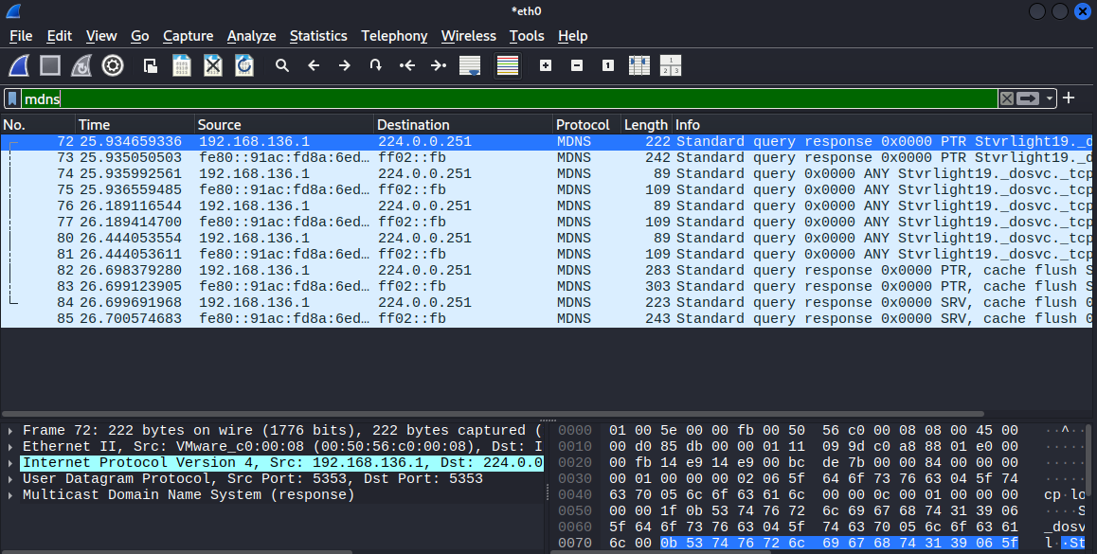

6.Identify at least 3 different protocols in the capture.
In your capture, the common protocols:
- DNS: Used for resolving domain names.
- MDNS: Local network name resolution without needing a central DNS server.
- ICMP: Ping-related traffic.
- ARP: Address Resolution Protocol for local networks.

7.Export the capture as a .pcap file.
• Go to File > Export Specified Packets
• Save with .pcap extension.
I saved my file as “wireshark_capture.pcap”.

8.Summarize your findings and packet details.
Protocols Found:
- DNS:
  - Request to www.google.com
  - Response with IP address 192.168.136.2
- ICMP_:
  - ICMP echo request/reply pairs during ping
  - Request IP: 192.168.136.129 & Reply IP: 142.251.221.110
- ARP:
  - Multiple ARP requests detected for local IP-to-MAC resolution.
- MDNS:
- Responses with IP addresses and services offered
- Queries (standard or service discovery)

